**University Of Petroleum And Energy Studies**

**Internship – High Level Design**

**On**

**Cloud-Based Bus Pass System**

**Team members:**

* Anirudh Kushwah (R110219015)
* Gaurav Porwal (R110219054)
* Kushagra Joshi (R110219061)
* Nayan Naugain (R110219090)
* Kumar Baibhav (R11021074)

* Guided by: Vijendra Singh
* Industry Mentor: Yogesh Ghorpade

|  |  |  |
| --- | --- | --- |
| **S. No** | **Title** | **Page No** |
| 1. | Scope of the document | 3 |
| 2. | Intended audience | 3 |
| 3. | System overview | 3 |
| 4. | Application Design | 4 |
| 5. | Process flow | 5 |
| 6. | Component Design | 6 |
| 7. | Details of frameworks | 7 |
| 8. | Interfaces | 8-9 |
| 9. | Session Management | 9 |
| 10. | Caching | 9 |
| 11. | Non-Functional Requirements | 10 |
| 12. | References | 10 |

**Introduction :**

A cloud-based bus pass system is useful to the people as it is easily available through the internet in contrast to the traditional bus pass system where the authority issued the pass to the user which is rather time-consuming and inconvenient. The user had to wait in long queues to get their passes. Therefore, a cloud-based system will overcome these limitations of the current public transport system. The project aims to provide a more convenient, reliable and efficient way to bus pass generation. As the complete system is online, hence it is faster than the previously used manual system. The users can access this system via the internet at anytime from anywhere. Now, the user can save time by avoiding the long queues. The passes are generated online so the chance of them being misplaced or stolen is minimal.

# Scope of the document

Earlier, the user had to visit the office and submit their details and wait for approval which is a time-consuming way. This is a digital approach where we can remove the limitations of the traditional system. With a digital pass the hassle of getting a physical pass is eliminated. This model provides the flexibility of issuing bus pass online. The main objective of this system is to automate pass issuing procedure and enable secure payments as well through the use of UPIs.

# Intended audience

The system can be used by any bus transport service. This model can be used by government or in the private sector to automate bus pass generation and save time and money. The intended user of this system is the general public. People working 9-5 jobs and students going to colleges or schools can now simply issue their passes online and save time by not waiting in long queues to get their pass. This is an efficient approach for the daily passenger in their day-to-day bus journey.

# System overview

.In the traditional system, pass generation and renewal was a manual process. The user had to visit the office and submit their details and wait for approval which is a time-consuming way. A cloud-based bus pass system is a digital approach where we can remove the limitations of the traditional system. With a digital pass the hassle of getting a physical pass is eliminated. This model provides the flexibility of issuing bus pass online. The main objective of this system is to automate pass issuing procedure and enable safe and secure payments as well through the use of UPIs.

**System Design:**

**Application Design**

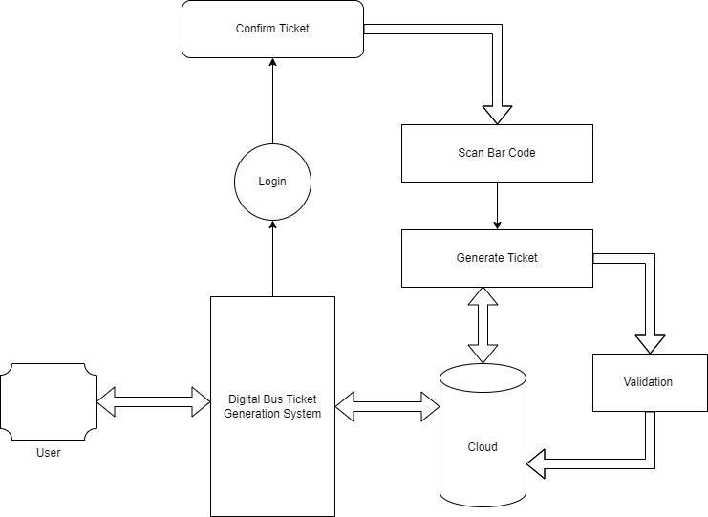

The user has to first register on the portal, if not already registered. Then only they can login to the website to generate their pass. The user can select their destination, bus timings and dates and generate the pass accordingly. Then they are directed to the edit pass page where they can edit and review the pass and they go the payment gateway where they pay the fare through master card or UPI. After this they can print a copy of the pass or keep an e-pass. Now the successful pass generation message is displayed.

**Processflow** 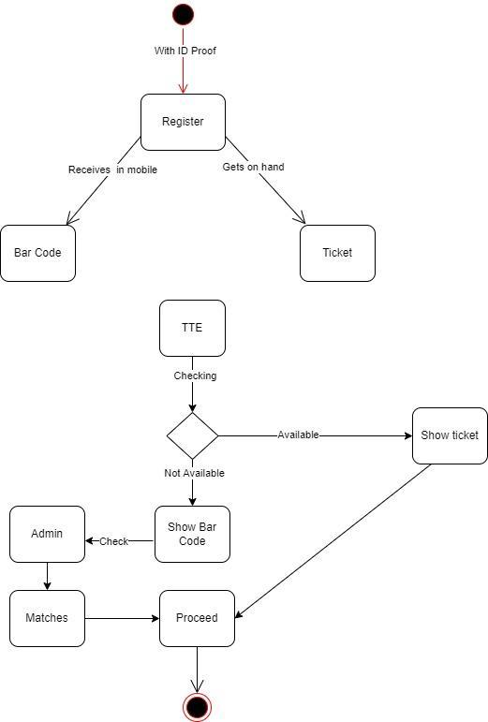

Firstly, the user registers on the portal and login using his credentials. For the generation of the bus pass, the user first submits the necessary documents like photo, address proof and identity proof and then the authority verifies these details and approve or reject accordingly. The users can check for the availability of the tickets and book them according to their needs. Once, the ticket is confirmed, an e-ticket is generated which the user has to carry while boarding the bus.

**Component Design**

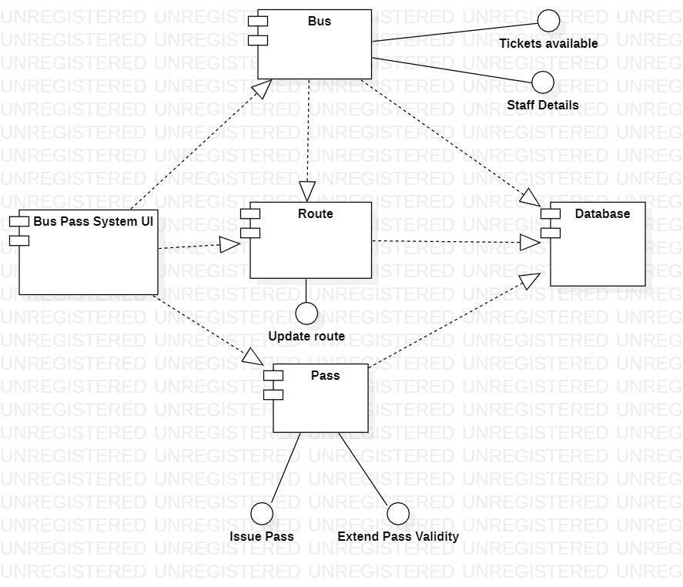

The bus pass UI is the page from where the user can register to our website and after successful registration, they can login by their user’s name and password. We have used Html, CSS, Java Script, Node JS to develop the bus pass UI which is hosted on AWS EC2 instance. This UI redirects the user to the page they can select the destination, bus timings and dates for their journey. All the bus details i.e route, destination, departure time, etc and user details i.e username,password,email,etc are stored in database.

# Details of framework

The bus pass system is developed using Hypertext Markup Language (HTML), Cascading Style

Sheets (CSS), JavaScript (JS), Bootstrap and Node.js ,Express.js and react. Database: Mongo DB is used to store and

maintain passengers’ information. The Non-Relational database was taken because it offers high

performance, high scalability, high reliability and Flexibility and for deploying the system AWS is used.

# Interfaces

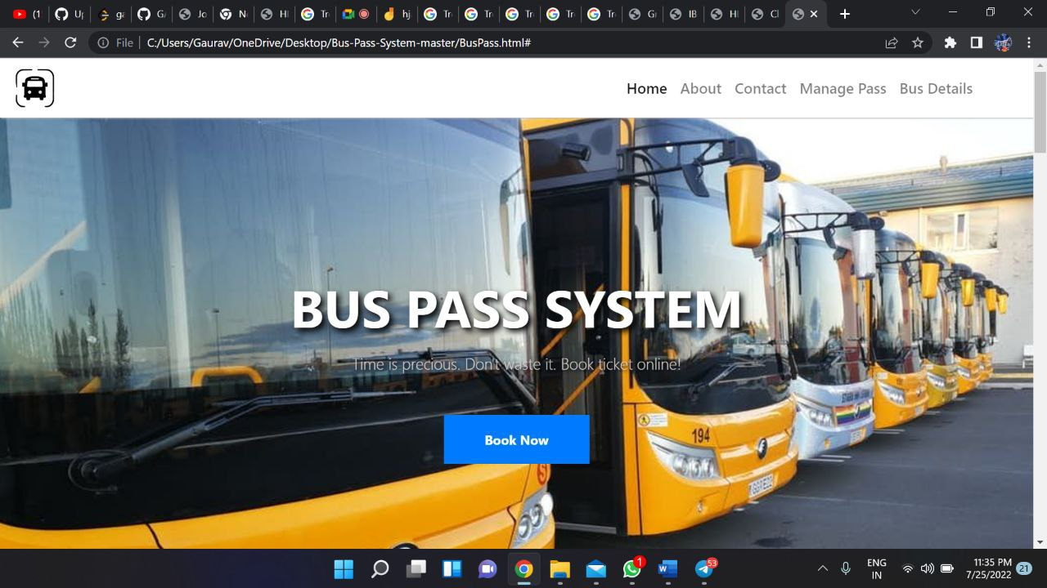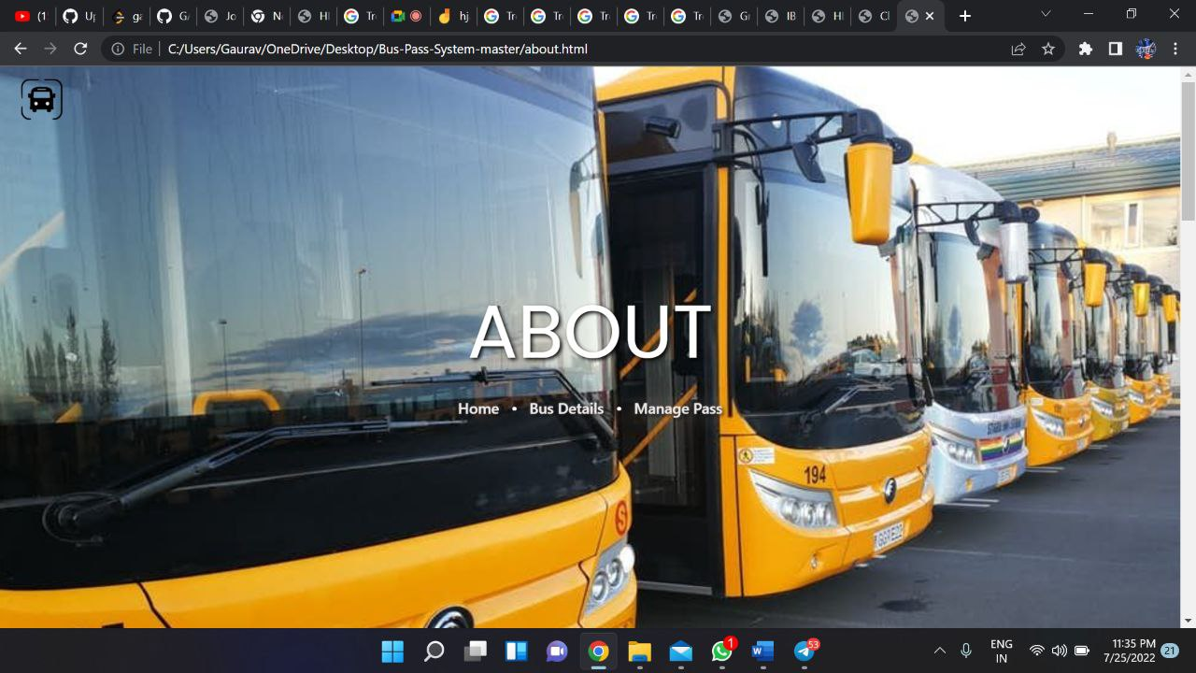

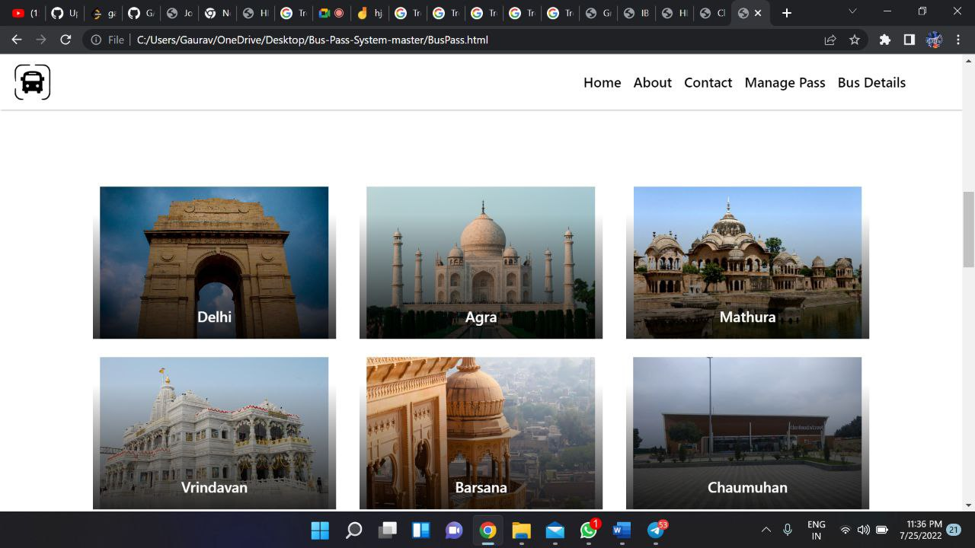

## Session Management

Session management refers to the process of securely handling multiple requests to a web based application or service from a single user or entity. It is used to facilitate secure interactions between a user and the service or application and applies to a sequence of requests and responses associated with that particular user.

response.

• User Authentication

• HTML Hidden Field

• Cookies

• URL Rewriting

## Caching

Caching is storing data in a location different than the main data source such that it's faster

to access the data. It is done to avoid redoing the same complex computation again and again. Caching in the Bus-Pass portal.

There are four types of caching in web paging-

• Site Caching

• Browser Caching

• Server Caching

• Micro Caching

**Non-functional Requirements**

**Security Aspect**

Security is an important point especially when our completely system is online. The data of the user must be stored in a safe and secure location. The communication medium must be encrypted and secure to prevent man-in-the-middle attacks. For our web application we are using firewall which act as a security layer against attackers. We should constantly monitor our systems for any kind of malware or failure. We are using the services of AWS which is the most popular and secure cloud computing environment. We can use AWS CloudTrail to keep track of user activities and the IAM service to securely access our resources. For network security we can use Virtual Private Network (VPN).

**Performance Aspect**

To increase the performance of our system we can do scaling of our servers. When the number of users increase, we must automatically scale up our resources for a pleasant user experience. We can use a load balancer which is used to distribute workload among multiple servers ensuring optimal resource utilization. Monitoring of resources must be done regularly and the faulty ones should immediately be checked and fixed.

### Reference

[1] https://www.researchgate.net/publication/329073305_Cloud-Based_E

Learning_Using_Cloud_Computing_Platform_for_an_Effective_E-Learning

[2] S. Kim, “Security Augmenting Scheme for Bus Information System based on Smart Phone”, International Journal of Security and Its Applications, vol. 7, no. 3,(2013), pp. 337-345.

(Accessed on 22 June 2022)

[3] J. Lee, K. Hong, H. Lee, J. Lim and S. Kim, “Bus information system based on smart-phone Apps”, in Proc.of KSCI Winter Conference (2012), pp. 219-222.

(Accessed on 25 June 2022)

[4] S. Chandurkar, S. Mugade, S. Sinha, M. Misal and P. Borekar, “Implementation of Real Time Bus Monitoring and Passenger Information System”, International Journal of Scientific and Research Publications, vol. 3, no. 5,(2013), pp. 1-5.

(Accessed on 25 June 2022)